shell工具seekcy用户连上服务器，
执行sudo vi /etc/cron.allow，输入seekcy用户密码：Joysuch@Locate2020

如果显示不包含下图内容

输入i进入编辑模式

将下列内容复制粘贴进去
seekcy
Seekcy

输入:wq保存退出
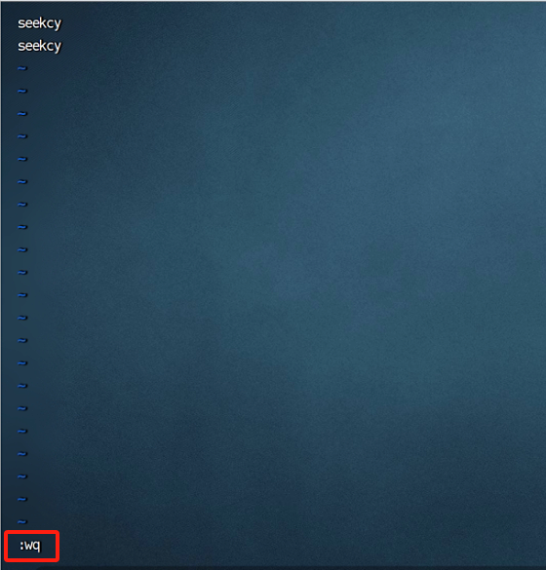

执行crontab -e
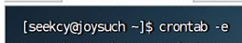
输入i进入编辑模式
将下列内容复制粘贴进去
MAILTO=""
0 2 * * * /home/seekcy/db_backup/backup_run.sh
@reboot /home/seekcy/database/start.sh
*/3 * * * * /bin/sleep 600; /home/seekcy/database/watchdog.sh
*/1 * * * * /home/seekcy/tools/system_monitor/bin/database.sh
@reboot /bin/sleep 30; /home/seekcy/softs/start.sh
*/3 * * * * /bin/sleep 630; /home/seekcy/softs/watchdog.sh
*/1 * * * * /home/seekcy/tools/system_monitor/bin/softs.sh
@reboot /bin/sleep 60; /home/seekcy/js_open/start.sh
*/3 * * * * /bin/sleep 660; /home/seekcy/js_open/watchdog.sh
*/5 * * * * /home/seekcy/tools/check_disk_space.sh
*/1 * * * * /home/seekcy/tools/system_monitor/bin/server.sh
*/1 * * * * /bin/sleep 1; /home/seekcy/pod-data/watchdog/service_watcher.sh
*/1 * * * * /bin/sleep 21; /home/seekcy/pod-data/watchdog/service_watcher.sh
*/1 * * * * /bin/sleep 41; /home/seekcy/pod-data/watchdog/service_watcher.sh
0 1 * * * /home/seekcy/pod-data/watchdog/clear_service_log.sh
@reboot /bin/sleep 240; /home/seekcy/chemical-locate/seekcy-stream/service-server.sh
*/3 * * * * /home/seekcy/pod-data/watchdog/stream_watcher.sh
0 1 * * * /home/seekcy/pod-data/watchdog/clear_stream_log.sh

按ESC
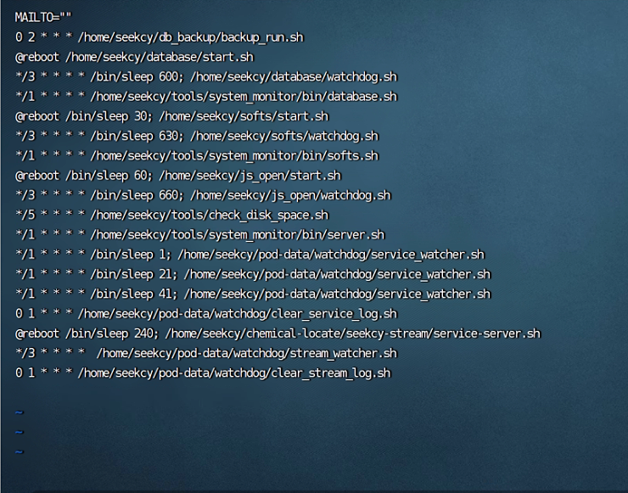
再输入:wq保存退出
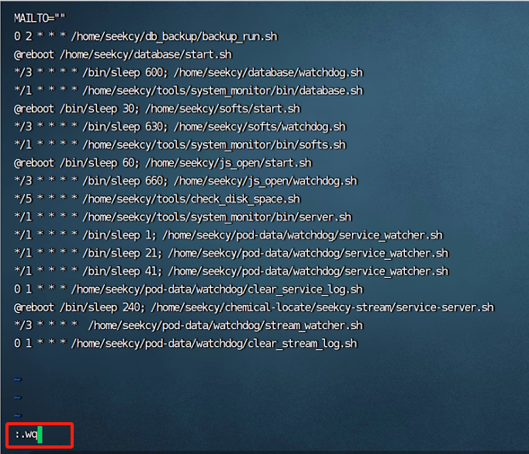
再执行sudo service crond restart重启定时任务，输入seekcy用户密码：Joysuch@Locate2020

看到下图就表示成功了
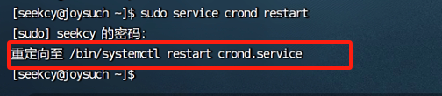

操作完成后等待15分钟，打开平台看看是否正常，不正常则服务器检查个服务是否正常。

